WOMEN AND ECONOMIC SECURITY IN MISSISSIPPI:
A DATA BRIEF
INTRODUCTION: COMPOUNDED CHALLENGES
Across the United States, many women face disparities in wages and employment while providing for their families and balancing child care and other family responsibilities.
The growing number of families headed by single mothers exacerbates these issues. In Mississippi, the prevalence of poverty, births to unmarried parents, and the interaction between gender and race disparities makes these challenges particularly detrimental to the state’s families. Attention is being paid on a national level to the gender pay gap and paid family leave. This data brief focuses on the status of women and economic security in Mississippi to inform policy development that addresses the unique challenges of women and families in Mississippi.
WAGES AND EMPLOYMENT

Labor force participation
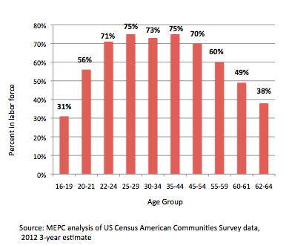
While not yet at the same level of employment of men, 54% of women over age 16 are in the labor force (compared with 63% of men). At first glance, this may seem like a low labor force participation rate; however, looking at labor force participation by age group tells a different story. As Figure 1 shows, women aged 22-54 have a 70-75% labor participation rate. In comparison, men have a labor force participation rate of 79-83% in that age group.
Figure 1: Labor Force Participation Among Women in Mississippi by Age Group

The wage gap
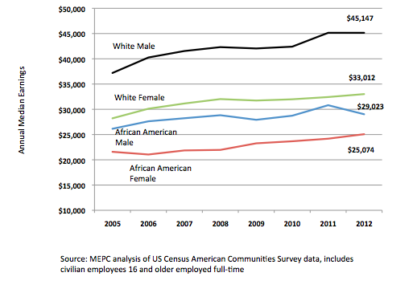
Women in Mississippi earn on average 71 cents per dollar of men’s earnings. Women on average earn less at every level of educational attainment and throughout almost every industry. Figure 2 shows the median earnings of Mississippians who are employed full-time by gender and race. It shows how race and gender interact in earnings disparities. White males earn the highest as a group among Mississippians, followed by white females, African American males, and African American females. White women earn 73% of white men, and African American women earn only 55% of white men. White women’s earnings as a group are higher than both African American men and women.
Figure 2: Median Earnings by Race and Gender in Mississippi

Occupational segmentation
To further understand gender pay disparities, it is important to look at employment and earnings across the different industries in Mississippi. In many cases, women and men still fall into occupations traditionally associated with their gender. Forty percent of working women in Mississippi work in education or health care, compared with 11% of men. Conversely, 35% of men in Mississippi work in construction, manufacturing, and agriculture, compared with 9% of women.

Figure 3 shows the gender composition of workers by industry. Women make up over 80% of workers in the largest industry in Mississippi, healthcare. The workforce of the second largest industry, manufacturing, is made up mostly of men at 70%. The fourth largest industry is education, of which women make up 72% of workers.

Education and health care provide higher wages than many of the other industries where many women are employed, like retail trade or food service. However, despite their high concentration in the health care field, the median earnings for women in health care are only 60% of men’s median earnings. Figure 4 shows the median earnings for men and women by industry.

Interestingly, earnings for women are much more in line with men’s earnings in fields that are less traditional, like construction. Construction is the only industry in Mississippi in which the median earnings for women are slightly higher (though within the margin of error) than men.

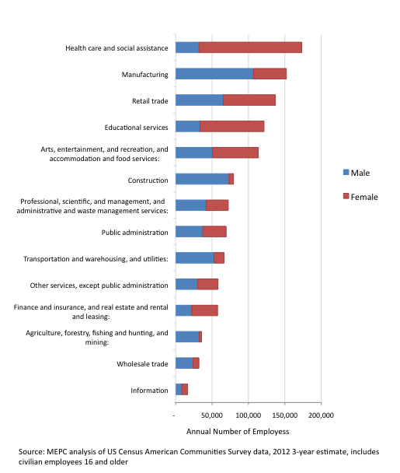
Figure 3: Number of Employees by Mississippi Industry, 2012

Figure 4: Median Earnings by Mississippi Industry, 2012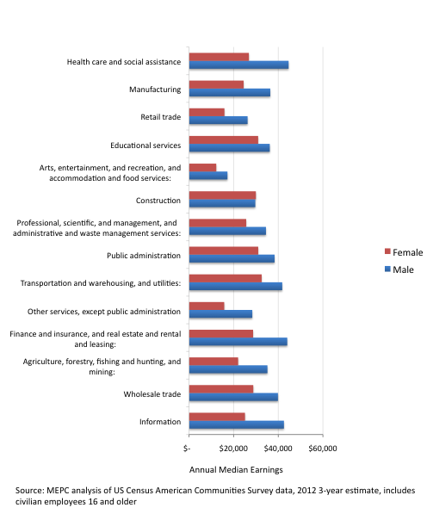

Educational attainment
The wage gap not only applies within industries, it is also still significant despite men’s and women’s educational attainment. At every education level, men in Mississippi still earn more than women. Figure 5 shows the median earnings by education level and gender. The gap is slightly smaller at lower levels of educational attainment.
Figure 5: Median Earnings by Educational Attainment and Gender

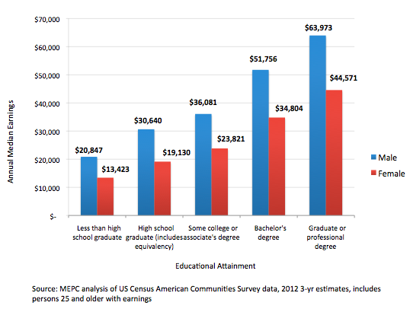

EDUCATION
Women and higher education
The previous figure shows that even despite the persistent gender wage gap across educational levels, in general, women and men who attain higher degrees earn higher wages. Women in Mississippi have higher educational attainment levels than men, but improving access to higher education is still key to improving the economic security for all Mississippians. Figure 6 shows the educational attainment levels of men and women in Mississippi.

Current enrollment trends also reflect growth in educational attainment among women compared to men. In the last ten years, total enrollment increased 20.4% among women and increased 17.4% among men. While enrollment is increasing, not all students who enroll will graduate with a degree. Figure 7 shows the graduation rates over the last nine years by gender and race. Among women, 61% of white women and 45% of African American women complete college.

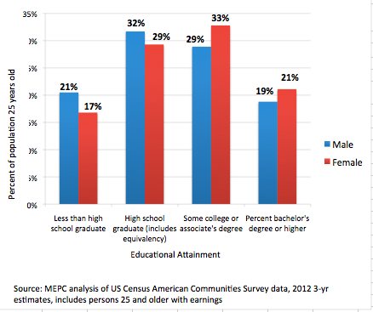
Figure 6: Mississippi Educational Attainment by Gender

Figure 7: Mississippi University Graduation Rates by Race and Gender

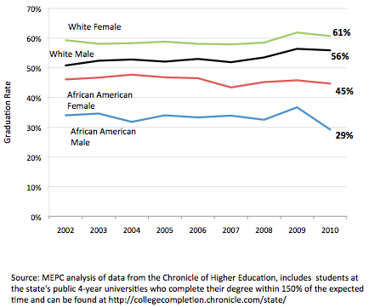

Student parents
One factor affecting college completion rates is the prevalence of births among college-aged women. Seventy percent of teen births in Mississippi (3,429) in 2012 occurred in college-aged teens. A recent survey from the Women’s Foundation of Mississippi and the Institute for Women’s Policy Research of female community college students found that just under a third of students have a child. Two out of three students who have a child while in community college do not graduate. Most state financial aid programs are not designed to help student parents, some of whom must take part-time class loads and/or take a few years of time off between high school and college.

Fields of study
Not surprisingly, the fields of study for women and men attending college largely reflect the same occupational segmentation seen in Mississippi’s employment data by industry. Figure 8 shows the percentage of female students in each field of study. Education and health fields of study both have a large majority of female students. Some science and math fields have a fairly even number, or even a majority of female students, suggesting some improvement in attracting women to Science, Technology, Engineering, and Mathematics (STEM) fields; however, computer and engineering fields still have mostly male students with only one in five students being female.

Figure 8: 2013 Female Students by Field of Study at Mississippi Universities

FAMILY SUPPORT

Family income
As the poorest state in the nation, the gender pay gap is very important in Mississippi. The wage gap hurts family income for both married-couple families and families headed by single women. The gap means less family income to pay for housing, transportation, healthcare, education, etc. It also means less money is spent in local economies. Figure 9 shows the median annual earnings by gender for Mississippi and the United States.

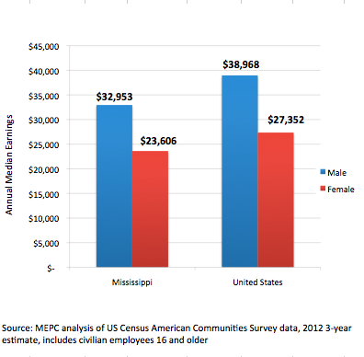
Figure 9: Median Annual Earnings by Gender

Median earnings in Mississippi for both male and female workers are about 85% of the average median earnings for the United States.

Family type
Because of the wage gap and challenges of taking care of family responsibilities alone, households headed by single women are much more likely to have a lower family income.

Figure 10 shows the difference in median earnings for families headed by a single mother compared with a married-couple family. The median earnings for a married-couple family are more than 2.75 times that of a single mother family.

In fact, of families living below poverty in Mississippi, 64% of them are headed by single women. There are more than twice the number of families in poverty who are headed by single women (86,774) than married-couple families (36,002).
Figure 10: Median Earnings by Family Type

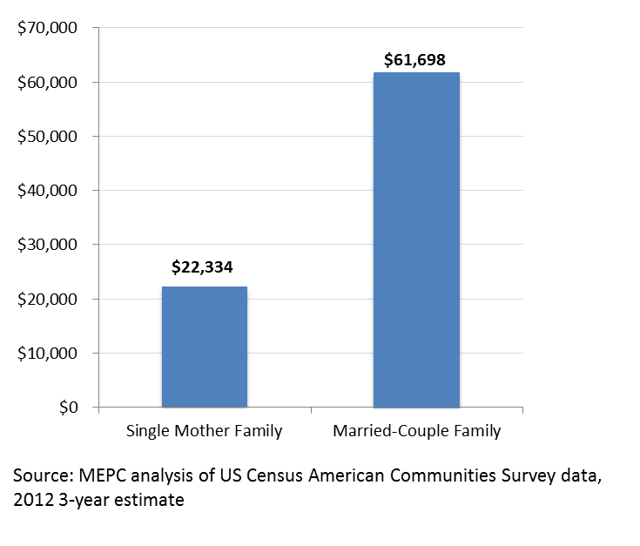
However, poverty is not a true measure of how
much a family needs to support themselves. A report from the Mississippi Economic Policy Center and Wider Opportunities for Women on the Basic Economic Security Tables illustrates the amount needed for family economic security. Figure 10 shows the basic economic security standard for families headed by a single parents compared with minimum wage and poverty income levels. Families need much more than the minimum wage or poverty level wages to support themselves. Many single-parent families, especially families headed by single mothers, are not earning enough to meet the needs of their families. Further, only 32% of female-headed families in Mississippi receive child support payments.

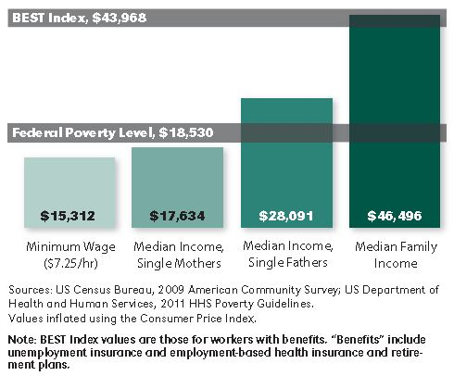
This problem is compounded by the prevalence of families headed by single parents in Mississippi. Mississippi ranks highest among states in the percentage of children living in single parent families at 49% of children. Current trends show that this will increase over the next few years as more children are born to unmarried parents in Mississippi. Mississippi has the highest percentage of births to unmarried parents at 55% of births. Since 1990, while remaining among the worst in the nation, the percent of births to unmarried women has increased from 41% of births to 55% of births. Nationally, the figure increased from 28% to 41% of births.
Figure 11: Basic Economic Security for Single Parent Families with 1 Worker, 1 pre-school aged child and
1 school-aged child

Child care
With so many women participating in the labor force (see Figure 1), access to quality child care is critical. This is especially true for single parent families.

For many families, however, quality child care is not affordable. According to data on family expenses from the Basic Economic Security Tables report, child care is the largest monthly expense for most families with two or more young children (BEST). However, many families cannot afford market rates for child care. Two out of three families headed by single mothers with a child 5 years old or younger live in poverty. State and federal subsidies for child care have not kept up with the need for child care support.

CONCLUSION
The data above include some of the areas that should be considered in policy development to improve the lives of women in Mississippi. Policy solutions should be broad, not only in addressing direct gender discrimination, but also by encouraging women to pursue non-traditional careers, improving state financial aid programs available for students who are mothers, improving paid family leave and sick leave policies, improving the affordability and availability of quality child care, and addressing teen pregnancy and unmarried births.

Mississippi Department of Health Vital Statistics Report 2012 available at http://www.msdh.state.ms.us/msdhsite/_static/31.html.
The National Campaign to Prevent Teen and Unplanned Pregnancy, “Unplanned Pregnancy among College Students and Strategies to Address It” July 2014 available at http://thenationalcampaign.org/sites/default/files/resource-primary-download/briefly-_unplanned_pregnany_college.pdf
Kids Count Data Center data for 2011 available at http://datacenter.kidscount.org/data/tables/66-female-headed-families-receiving-child support?loc=26&loct=2#detailed/2/26/false/867,133,38,35,18/any/366,367

